Social Media Toolkit
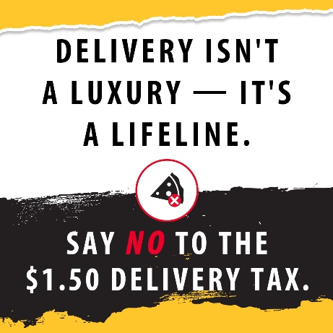

Delivery Tax Social Draft: "Stop the Delivery Tax"
A proposed $1.50 tax on home deliveries would have hurt working families across Illinois, especially those who rely on deliveries for groceries, diapers, and meals. These services aren't a luxury. They're essential.
Senator Plummer blocked this harmful tax for now. Let’s keep fighting policies that punish everyday people. Click here to sign the petition: Say NO to Higher Taxes on Illinois Families - Jason Plummer
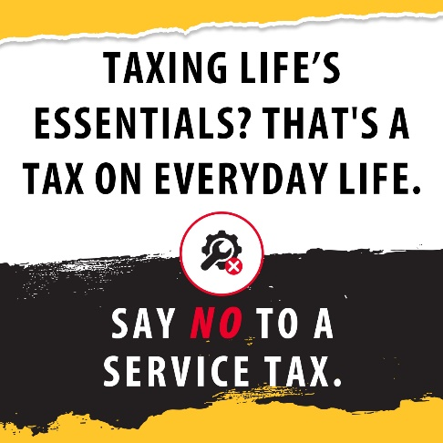

Service Tax Social Draft: "Stop the Service Tax"

Need your car fixed? Furnace repaired? Just trying to afford a haircut? (Personalize to your business)
The proposed service tax would have made life more expensive for every Illinois family Enough is Enough.
Say NO to tax hikes on daily necessities!

Senator Plummer is fighting against tax hikes. Click here to sign the petition: Say NO to Higher Taxes on Illinois Families - Jason Plummer

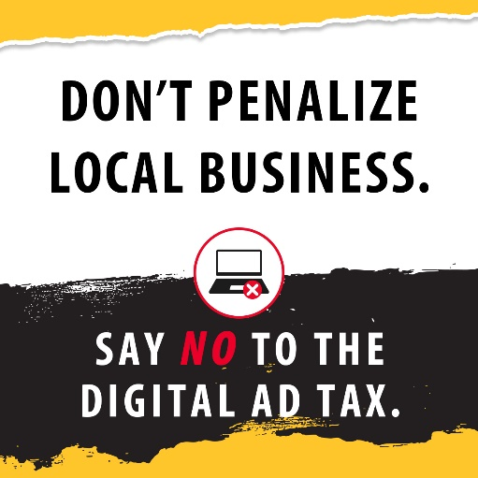

Digital Ad Tax Social Draft: “Stop the Digital Ad Tax”

Illinois small businesses depend on affordable digital ads to reach new customers and grow.
A digital ad tax would have punished local shops just for trying to stay afloat.
Say NO to a digital ad tax and support the businesses that support our communities.

Senator Plummer is leading the fight against higher taxes. Click here to sign the petition: Say NO to Higher Taxes on Illinois Families - Jason Plummer

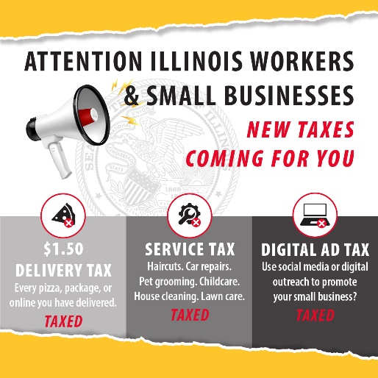

General Social Draft
Illinois families are already facing enough. But Democrat lawmakers keep demanding more, proposing:
- $1.50 Delivery Tax on everyday necessities
- New Service Tax on basics like oil changes and haircuts
- “Mom & Pop” Ad Tax hurting small businesses and families
Enough is enough. Join us in taking a stand against tax hikes that would hurt working families, local jobs, and community businesses!
Click here to sign the petition: Say NO to Higher Taxes on Illinois Families - Jason Plummer

